Development and Implementation of Investment Plans in Health Employment and Economic Growth: Lessons learned from West African Economic and Monetary Union (WAEMU) Member States

Human resources for health. We will create decent work and appropriate compensation for health professionals and other health personnel working at the primary health care level to respond effectively to people’s health needs in a multidisciplinary context. We will continue to invest in the education, training, recruitment, development, motivation and retention of the PHC workforce, with an appropriate skill mix. We will strive for the retention and availability of the PHC workforce in rural, remote and less developed areas. We assert that the international migration of health personnel should not undermine countries’, particularly developing countries’, ability to meet the health needs of their populations.

Statement from Heads of State and Government, Ministers and Representatives of States and Governments, attending the International Conference on Primary Health Care, Astana - 2018.

January 2023

Introduction
In 2016, the United Nations Commission on Health Employment and Economic Growth (The Commission) recognized the paramount importance of health and care workers for health systems, economic growth and communities’ well-being. Investing in the health employment is considered as "a privileged opportunity to design and implement a new policy framework in the various and essential sectors for sustainable development" [1]. In particular, achieving Universal Health Coverage (UHC) requires strengthening Health Workforce (HWF) in sufficient quantity and quality, in the right place and satisfied with their living and working conditions. Strengthening HWF also remains necessary to make health systems more resilient during public health emergencies, such as COVID-19 pandemic.
The Commission propose actions in support of the creation of around 40 million new jobs in the health and social sector by 2030, paying specific attention to addressing the projected shortage of 18 million health workers by 2030, primarily in low- and lower middle-income countries. These actions will need to contribute to global inclusive economic growth, creation of decent jobs and achieving Universal Health Coverage, and also to complement the various global development efforts set by the international community [1]. Its recommendations covered 10 main area: 1) Job creation; 2) Gender and Women’s Right; 3) Education, Training and Skills; 4) Health Service Delivery and Organization; 5) Technology; 6) Crises and Humanitarian settings; 7) Financing and Fiscal space; 8) Partnership and Cooperation; 9) International migration and 10) Data, Information and Accountability (Box below).
The member States of the West Africa Economic and Monetary Union (Benin, Burkina Faso, Cote d’Ivoire, Guinea-Bissau, Mali, Niger, Senegal and Togo) were fully involved during the series of works conducted by the Commission in sub-Saharan Africa [2]. They were also the first ones in the world to translate the recommendations of the Commission into national and regional investments plans. The purpose of this policy brief is to summarize the lessons learned from the process of developing and implementing the national and regional action plans for investment in health employment and economic growth in WAEMU countries. It specifically underlines the progress made and the persistent challenges on the following: 1) Regional prospects to investments in Health and Care Employment; 2) Evolution of the numbers, densities and needs of health personnel; 3) Needs of nurses and midwives for Universal Health Coverage; 4) Institutionalization of mechanisms for producing factual data on HRH; 5) Improving the quality of initial and ongoing health training; 6) Enhance HWF deployment and retention in underserved areas.

High-Level Commission on Health Employment and Economic Growth: Recommendations to transform the health workforce for the SDGs
- JOB CREATION: Stimulate investments in creating decent health sector jobs, particularly for women and youth, with the right skills, in the right numbers and in the right places.
- GENDER AND WOMEN’S RIGHTS: Maximize women’s economic participation and foster their empowerment through institutionalizing their leadership, addressing gender biases and inequities in education and the health labour market, and tackling gender concerns in health reform processes.
- EDUCATION, TRAINING AND SKILLS: Scale up transformative, high-quality education and lifelong learning so that all health workers have skills that match the health needs of populations and can work to their full potential.
- HEALTH SERVICE DELIVERY AND ORGANIZATION: Reform service models concentrated on hospital care and focus instead on prevention and on the efficient provision of high-quality, affordable, integrated, community-based, people-centred primary and ambulatory care, paying special attention to underserved areas.
- TECHNOLOGY: Harness the power of cost-effective information and communication technologies to enhance health education, people-centred health services and health information systems.
- CRISES AND HUMANITARIAN SETTINGS: Ensure investment in the International Health Regulations core capacities, including skills development of national and international health workers in humanitarian settings and public health emergencies, both acute and protracted. Ensure the protection and security of all health workers and health facilities in all settings.
- FINANCING AND FISCAL SPACE: Raise adequate funding from domestic and international sources, public and private where appropriate, and consider broad-based health financing reform where needed, to invest in the right skills, decent working conditions and an appropriate number of health workers.
- PARTNERSHIP AND COOPERATION: Promote intersectoral collaboration at national, regional and international levels; engage civil society, unions and other health workers’ organizations and the private sector; and align international cooperation to support investments in the health workforce, as part of national health and education strategies and plans.
- INTERNATIONAL MIGRATION: Advance international recognition of health workers’ qualifications to optimize skills use, increase the benefits from and reduce the negative effects of health worker migration, and safeguard migrants’ rights.
- DATA, INFORMATION AND ACCOUNTABILITY: Undertake robust research and analysis of health labour markets, using harmonized metrics and methodologies, to strengthen evidence, accountability and action.

Lessons learned

Regional context and prospects for investment in health employment and economic growth
The WAEMU Member States developed and implemented their regional and national investment plans for health employment and economic growth to reach several objectives. On the one hand, these plans were effective instruments used to translate The Commission’s recommendations into actions and solutions to alleviate the acute HWF crisis, in particular some challenges directly related to health labor market : miss-production (underproduction for some health professions and overproduction for others), the underemployment, distribution inefficiencies (Rural vs. Urban areas; First vs. Second vs. Third levels of the health pyramid), low performance in delivering health and care services; and underfunding of HRH policies to address these challenges [4]. They also presented “major opportunity to foster political commitments and to make gains across several Sustainable Development Goals, including SDG 1 (poverty elimination), SDG 3 (good health and well-being), SDG 4 (quality education), SDG 5 (gender equality) and SDG 8 (decent work and economic growth)” [1].
In the other hand, these investment plans contributed to make significant progress on some regional milestones. In fact, the WAEMU’s Amended Treaty strongly encourages Member States “to institute a coordination of national sector-based policies through the implementation of common actions, and possibly common policies and strategies, particularly in and between the following areas: human resources, land use planning, agriculture, energy, industry, mines, transport, infrastructure and telecommunications” [1]. At a continental level, the African Union Agenda 2063, in its "Income, employment and decent work" component, urges Member States to: a) Increase per capita incomes by at least 10 times by 2063; b) Maintain the level of unemployment below 6%; c) Reduce by 75% the number of adult workers in precarious employment; d) Reduce youth unemployment to 6% or less; e) Reduce the unemployment rate in rural areas by 50% by 2030 and eliminate it by 2050; f) Raise 20% of informal sector enterprises to the level of small and medium enterprises each year from 2025 [5]. On its part, the African Development Bank initiative for “Youth Employment in Africa” aims to “create 25 million jobs and have an impact on 50 million young people”.
Main common objectives of the West African Economic and Monetary Union (WAEMU)
- Strengthen the competitiveness of Member States' economic and financial activities in the context of an open and competitive market and a streamlined and harmonized legal environment.
- Ensure the convergence of the performance and economic policies of the Member States through the establishment of a multilateral surveillance procedure
- Create a common market between Member States based on the free movement of persons, goods, services, capital and the right of establishment of persons exercising a self-employed or salaried activity, as well as on a common external tariff and a trade policy
- Establish coordination of national sectoral policies through the implementation of common actions, and possibly common policies, particularly in the following areas: human resources, land use planning, agriculture, energy, industry, mines, transport, infrastructure and telecommunications
- Harmonize, to the extent necessary for the proper functioning of the common market, the laws of the Member States and, in particular, the fiscal arrangements.
Source : Amended WAEMU Treaty, https://www.uemoa.int/

Development and functionality of multisectoral policy dialogue mechanisms
The process of developing the national and regional action plans has been conducted through multisectoral, inclusive and iterative approaches. They were led by the senior management (General Secretaries or General Directors, Directors of Cabinet and Ministers) from various sectors: Health, Employment, Education, Social Protection, and Finance. Depending on the country, several successive steps have been undertaken: 1) National workshops to identify and prioritize interventions ; 2) Technical retreats for program development and cost estimation; 3) Experience sharing at county and national levels; 3) Regular Communications during the Councils of Ministers to get involved all Members of the Government ; 4) Government Seminars; 5) Parliamentary days; 6) National validation; 7) High-level advocacy for resource mobilization at national and international level. These frameworks and approach have been maintained as models for high level technical and political dialogues in WAEMU countries and expanded other countries (Chad, Guinea, and Mauritania). The continuous dialogue between these different multi-sector bodies is considered as a strength and an important asset to improve progress in HRH development.

Labour force trends, densities and needs
Between 2018 and 2021, WAEMU countries recruited about 24,500 physicians, nurses and midwives, representing a net increase of 27% in the health workforce (data are not available to estimate all recruitments made for all other cadres on 4 years in the 8 countries). According to the countries and based on the relative shares (%), one or two professional categories were prioritized at the national level. Midwives represented about half (48%) of new employees in all three categories, with proportions reaching 51% in Benin, 58% in Senegal and 94% in Burkina Faso. The increase in nurses (35% of new staff in these three categories at WAEMU level) was relatively more predominant in Benin (38%), Niger (44%), Togo (46%) and Cote d’Ivoire (56%). Doctors (+17% of new WAEMU staff in these three categories) represented respectively 25%, 29% and 44% of the increase in staff in Togo, Guinea Bissau and Burkina Faso. Some countries, affected by security and socio-political crises, recorded a decrease in the number of midwives (-24% in Mali) and nurses (-38% in Burkina Faso).
Graph 1: Net increase of doctors, nurses and midwives in WAEMU countries between 2018 and 2021
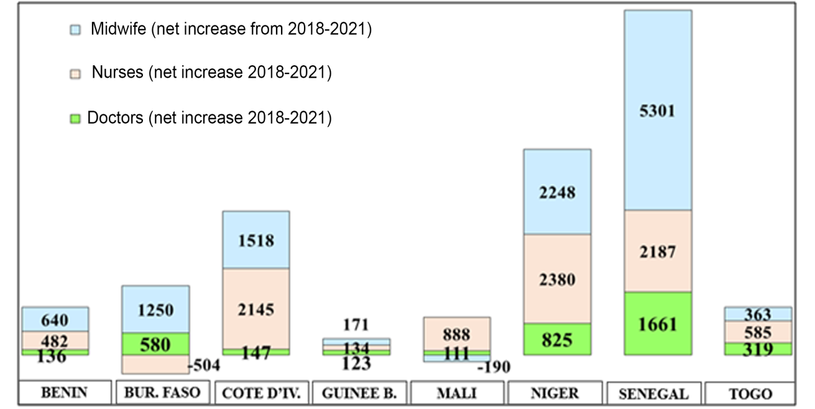
Sources: National Health Statistics Yearbooks (2018 to 2022) & WHO Global Health Observatory & WDI (2022)
Despite the recruitments made, the densities of health workers (Doctors, nurses and midwifes) were not significantly improved (Graph below). In fact, the recruitment efforts – essentially made by the public sector – have been absorbed by the needs induced by population growth and health workers attrition (Replacement of retiring and resigning health workers). Greater investments are required to adequately cover these induced needs and to ensure the availability of health workers to reach UHC objective.
Graph 2 : Trend (2018-2021) in health workers densities in WAEMU countries.
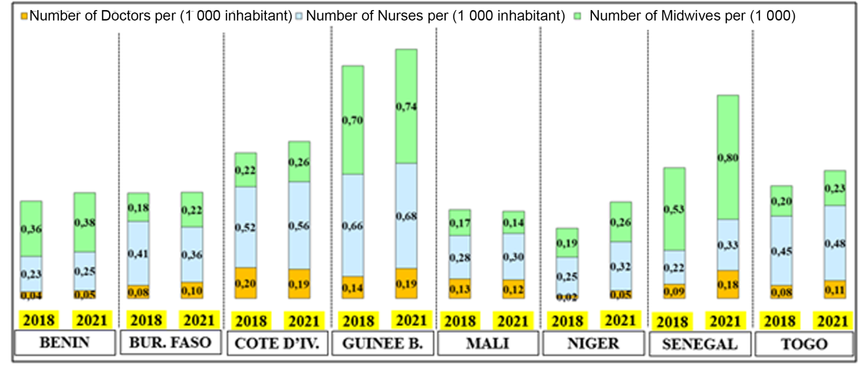
Sources: National Health Statistics Yearbooks (2018 to 2022) & WHO Global Health Observatory & WDI (2022)

Nursing and midwifery needs for Universal Health Coverage
One of the main challenges to achieving UHC is the adequate and equitable availability of health Workforce. Looking ahead to UHC and taking into account current trends, the WAEMU zone will face a shortage of around 340,000 nurses, with 71% of these needs identified in four of the eight WAEMU countries: Niger (22%), Côte d'Ivoire (19%), Mali (16%) and Senegal (13%).
Graph 3: Estimation of nursing staff needs in WAEMU countries
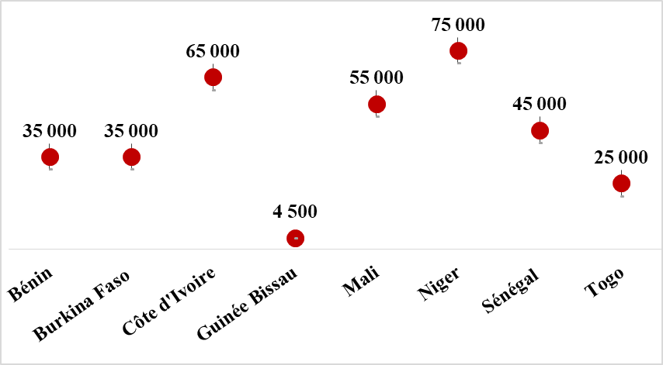
Sources: Based on data from the National Health Workforce Accounts (2018)

Institutionalization of mechanisms for producing evidence on HRH
Significant progress has been made by WAEMU countries in developing and using new evidence generating mechanisms and tools, thereby promoting better HWF planning and decision-making (table below). Indeed, the processes of health labor market analysis (HLMA) and national health workforce accounts (NHWA) development, carried out by almost all the WAEMU countries, have resulted in the examination of the root causes that hinder the development of HWF and the identification of effective public policy levers to better: i) adapt initial and continuous training to the population and health facility’s needs; ii) manage migrations flows; iii) increase recruitment; iv) integrate the private sector in health training and service provision; (v) improve the distribution, management and performance of health workers. Although the root causes and policy levers have been well identified, the expected effects from the corrective interventions – if these are sustained – will be observed in the medium and long terms.
Furthermore, the estimation of health workforce needs based on workload indicators (WISN approach) facilitated a productive dialogue between HWF Managers in the public sector (central, intermediate, and peripheral levels), Councils and Associations of health professionals, Health data Managers and Specialized health services (mother and child healthcare, reproductive health, family planning, nutrition, communicable diseases, non-communicable diseases, etc.). This important exercise made it possible to better assess the health personnel needs in the health facilities (Health Centers, District Hospitals).
The holistic approaches of HLMA, NHWA and WISN and the WAEMU countries’ commitment to update their results every 5 years offer to policy makers strategic and operational information to guide their decision, mainly during technical and political dialogues between public stakeholders (Education, Health, Civil Service, Decentralization, Planning, Finance and Budget, etc.) and partners supporting HWF development. In addition, they have enabled WAEMU countries to revitalize information platforms related to the various components of HWF development and management, in particular Training (Teaching and training, Regulation and accreditation, Financing of training), Recruitment and management (staff, labor market flows, employment characteristics and working conditions, expenditure and remuneration) and adequacy to the population needs (composition of the skill mix, Governance and policies, Systems of information). Thus, there are: i) a better synergy between public and private actors involved in the production and use of data; (ii) improved timeliness, completeness, and quality of collection of key HWF indicators.

Table 1: Mechanisms for providing factual data and improving the quality of initial and continuing health education in WAEMU countries.
 | BENIGN | BURKINAFASO | COTE D’IVOIRE | GUINEA | MALI | NIGER | SENEGAL | TOGO | TOTAL - WAEMU
Health Labor Market Analysis | X | X | X | X | X | X | X | X | 8
Development of National Health Workforce Accounts | X | X | X | X | X | X | X | X | 8
Analysis of the impact of COVID-19 on HRH | X | X | X | X | X | X | X | X | 8
Evaluation/Preparation of the HRH Development Plan | X | X | X |  | X | X | X | X | 7
Accreditation mechanisms for health training institutions |  |  |  |  | X | X |  |  | 2
Annual National exams for health graduations |  | X |  |  |  | X | X |  | 3
Regional Center of Excellence (Health Schools) to strengthen initial/continuing training in West African countries |  |  | X |  | X | X |  |  | 3

Effects of institutionalizing national health workforce accounts through the conceptual framework of health labor market analysis at country level:
- Enable better knowledge of HWF, including issues relating to equity
- Produce quality information to facilitate policy decision-making, in line with country needs
- Help guide and facilitate the transformation and expansion of health workforce education and training for UHC
- Assist in cross-sectoral policy dialogue between relevant ministries (e.g. ministries of education, health and finance)
- Facilitate priority investments needed to strengthen HRH and support UHC implementation
At regional and global levels:
- Improve the comprehensiveness, quality and comparability of HRH data in a sustainable manner.
- Encourage transnational cooperation on data collection and experience sharing.
Source: WHO, 2018, Understanding National Health Workforce Accounts

Improving the quality of initial and continuing health training
In Burkina Faso, Niger and Senegal, the Ministries of Health Departments in charge of HWF development have also initiated a new dynamic to operationalize or, better, institutionalize accreditation mechanisms for public and private health training institutions and health facilities. Results from Health Labor Market Analysis in these countries have shown that efficiency gains are highly possible by strengthening the quality of initial training, rather than investing in continuing education which is 2 to 5 times more expensive and creates distortions in the supply of healthcare due to long-term absences (3 to 15 months) of an important number (100 to 350) of health professionals from public health facilities. The mechanisms of accreditation and certification provide a governance and dialogue framework between public and private stakeholders involved in health training and healthcare supply. They covered training conditions and capacity, process of graduation and delivering diplomas (national exams for health graduation), support for public and private institutions to improve the quality of training and ensure their adequacy with the demand for health care and services.
In addition to national initiatives, some Regional Centers of Excellence for health training were developed to improve the quality of initial and continuing workforce training for reproductive, maternal, neonatal, child health. After strengthening their organizational and institutional capacities, these centers welcome students from West African French-Speaking Countries for specialized training (Master's level) in Health Sciences Pedagogy (at National Institute for Health Training - INFAS in Abidjan, Cote d’Ivoire), in Management of Health Services (at National Institute for Training in Health Sciences – INFSS of Bamako, Mali) and in Obstetrics Gynecology (at National School of Public Health – ENSP of Niamey, Niger). Positive externalities were also recorded in other health training institutions which were not selected as Regional Centers of Excellence. The external evaluations conducted presented dimensions where progress should be made to improve the quality of the training and to convergence toward the level of the Regional Centers of Excellence.
Improving the quality of initial training at national level could also be an effective way to reduce health workers emigration from WAEMU to OECD countries. Most of the health workers immigrated from WAEMU to OECD countries went first as students for initial or continuous training. In both 2010 and 2018, health students in WAEMU countries accounted for around 10% of African students enrolled in medical training in France. To understand this phenomenon as a whole, it is important to develop innovative approaches to follow migration flows from WAEMU countries to major destinations (OECD, North Africa, etc.) such as the WHO Code of Practice for International recruitment.
Table 2: Evolution 2010-2018 of t he number of foreign students enrolled in medical training in France (first, second and third cycles)
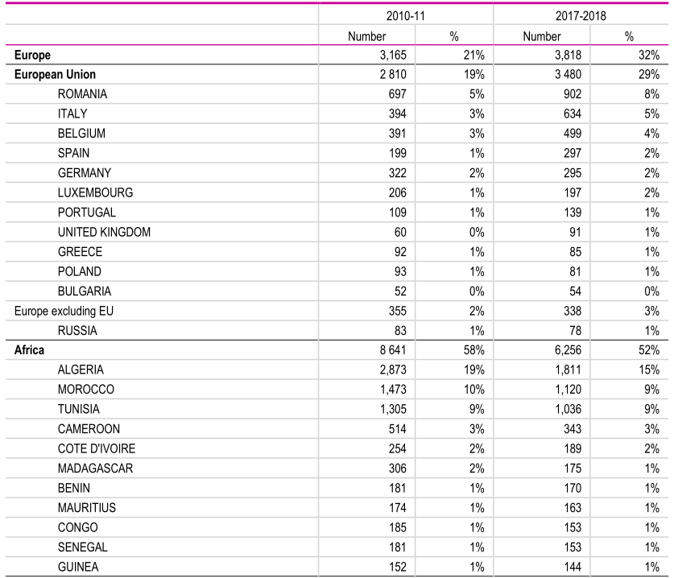

Source: OECD, 2019, Recent Trends in International Migration of Doctors, Nurses and Medical Students

Improved deployment and retention of HRH in underserved areas
As part of the revitalization of primary health care, WAEMU countries have strengthened mechanisms to deploy and retain health workers in underserved areas. In Niger, an ease of integration into the public service is granted to general practitioners through recruitment, without going through the competitions to which paramedics and other professional categories are subjected, taking into account the significant unmet needs in the system health. But when applying, they complete and sign a sworn commitment form to agree to serve outside the Capital for at least 3 years, before any request for assignment or redeployment (mandatory validation clause during application). In Benin and Mali, a pilot initiative to promote community general practitioners has been implemented, through public and private partnerships (PPP) and participatory and inclusive processes. It aims both to significantly improve the rate of availability (supply) and the rate of accessibility of populations (demand) to quality primary healthcare and services in rural areas; reducing the unemployment rate of young doctors and improving local health governance. The progress and results achieved in these areas have opened up new prospects for expansion at national and even regional level (WAEMU, West Africa). This initiative is similar to the Rural Pipeline approach piloted in Niger and Mali.

Project for the medicalization of rural areas through the recognition of community general practitioners (CGP) in Benin, Guinea and Mali
Initial observation/context: Qualified doctors are more and more numerous but remain in urban areas often in a precarious situation, even unemployed, while the majority of populations (60 to 80%) live in rural areas that have become medical deserts.
Overall objective: Strengthen sustainable access to quality primary health care through training, installation support and capacity building for community general practitioners (CGP) in rural areas (Benin, Guinea, Mali)
Funding & Project Period: 2.1 million euros from French Development Agency for the period 2019-2022
Expected results: 1) Improvement of 1^{rst} line health coverage in rural areas, with the strengthening and extension of the CGP network; 2) Strengthening and recognition of professional CSOs representing CGP as the main interlocutors of public health officials; 3) Reinforcement of the framework for the practice of general community medicine according to a multi-stakeholder approach; 4) Capitalization and sharing in West Africa.
Stakeholders: Ministries in charge of health and higher education ■ Faculties of medicine ■ NGOs Santé Sud ■ Local CSOs involved in general community medicine ■ DataSanté (computerized medical file for patients in rural health centers).
Operational approach: 1)Information and sensitization of general practitioners to the particularities and the concept of medicine in rural areas; 2) Specific training of volunteers in community general medicine within partner Faculties of Medicine (Creation of a course and a university degree in Parakou, Benin); 3) Identification and validation of installation sites in consultation with the decentralized authorities (municipalities); 4) Rehabilitation or construction and equipment of health centers, with local accommodation for the doctor; 5) Contractual arrangement (relief) with the community for operating costs; 6) Partnership agreement with the Ministry of Health for a legitimate place in the health system and a well-defined role; 7) Private law contract for the community general practitioner with a 1^{rst} line public health structure to ensure medical responsibility or liberal practice in his own private center with a public service association agreement; 8) Follow-up, continuous training and networking for community general practitioners • Experienced referent (mentor) • Quarterly continuous training program • Association of CGPs • Research-Action workshops (specific pathologies, improvement of the quality of practices and care) • visits by experienced general practitioners from the North (companionship).

Sources: AFD, 2022, & Health South,

Conclusion
The development and the implementation of national and regional investment plans in health employment and economic growth by the WAEMU countries have led to several innovations and a virtuous dynamic in increasing the number of health workers, improving the quality of initial and continuing health training, strengthening mechanisms for deploying and retaining HWF underserved areas, and strengthening HWF planning and governance. They have also significantly increase the leadership of the Departments in charge of HWF Development, which now act as a network at country to coordinated their strategic and operational actions. The various regional legislative and regulatory frameworks (WAEMU, ECOWAS, AfDB, African Union), favorable to investments in HWF and synergies of interventions between States, have facilitated an intersectoral and multi-actor approaches, beyond national borders.
However, the recruitments carried out by the WAEMU countries (in particular the 24,500 doctors, nurses and midwives) were insufficient to cover the needs induced by population growth and health facilities and to significantly improve the densities of health workers. Moreover, the advent of the COVID-19 pandemic – notwithstanding its repercussions on the health workforce, on the health system and on the economy – has offered important opportunities to considerably increase public and private investments in HWF. Unfortunately, these opportunities have not been sufficiently seized by stakeholders in the health sector, in particular the ministries in charge of health and employment.
To ensure continued progress towards Universal Health Coverage in the WAEMU sub-region, the countries should, on the one hand, consolidate the progress made from the implementation of investment plans in health employment and economic growth. On the other hand, they must update these investment plans to better take into account the new public health challenges. In addition, support and advocacy at higher levels (Prime Minister or Presidency of the Republic) are necessary. At the regional level (WAEMU, WAHOOAS), it is fundamental to integrate in the macroeconomic convergence critieria and mechanisms, some components related to the resilience of education and health systems; health human resources being at their crossroads. In this new dynamic, technical and financial support is more essential than ever.

Bibliography
- World Health Organization and the United Nations Children’s Fund (UNICEF), 2018, Declaration of Astana. Global Conference on Primary Health Care: From Alma-Ata towards universal health coverage and the Sustainable Development Goals. Astana, Kazakhstan, 25 and 26 October 2018.
- Commission de haut niveau sur l’Emploi en Santé et la Croissance économique, 2016, S’engager pour santé et la croissance : Investir dans le personnel de santé. Rapport de la Commission.
- Organisation mondiale de la Santé, Bureau régional de l’Afrique, 2020, Cadre régional de mise en œuvre de la stratégie mondiale sur les ressources humaines pour la santé à l’horizon 2030.
- Organisation mondiale de la santé (OMS), 2021, Personnels de santé : Orientations stratégiques mondiales pour les soins infirmiers et obstétricaux. Rapport du Directeur general.
- Benin, 2018, Plan d’Action National d’investissement dans les emplois du secteur sanitaire et la croissance économique
- Burkina Faso, 2018, Plan d’Action National d’investissement dans les emplois du secteur sanitaire et la croissance économique
- Côte d’Ivoire, 2018, Plan d’Action National d’investissement dans les emplois du secteur sanitaire et la croissance économique
- Guinée-Bissau, 2018, Plan d’Action National d’investissement dans les emplois du secteur sanitaire et la croissance économique
- Mali, 2018, Plan d’Action National d’investissement dans les emplois du secteur sanitaire et la croissance économique
- Niger, 2018, Plan d’Action National d’investissement dans les emplois du secteur sanitaire et la croissance économique
- Senegal, 2018, Plan d’Action National d’investissement dans les emplois du secteur sanitaire et la croissance économique
- Togo, 2018, Plan d’Action National d’investissement dans les emplois du secteur sanitaire et la croissance économique
- World Health Organization (WHO), Maintaining essential health services: operational guidance for the COVID-19 context. Interim guidance, 2020.
- World Bank, 2022, World Development Indicators.
- World Health Assembly (WHA), 2021, WHA74.14: Protecting, safeguarding and investing in the health and care workforce.
- Richard Horton, Edson C Araujo, Haroon Bhorat et al., 2016, Rapport final du groupe d’experts de la Commission de haut niveau sur l’Emploi en Santé et la Croissance économique.
- Global health alliance and world health organization, 2014, A universal truth : No health without a workforce third global forum on human resources for health report.
- World Health Organization, 2017, Leave no one behind: strengthening health systems for UHC and the SDGs in Africa. WHO Regional Office for Africa, Brazzaville, Congo.
- Bénin, 2018, Profils-Pays des Comptes Nationaux des Personnels de Santé
- Bénin, Annuaires nationaux des statistiques sanitaires (2018 à 2021)
- Burkina Faso, 2018, Profils-Pays des Comptes Nationaux des Personnels de Santé
- Burkina Faso, Annuaires nationaux des statistiques sanitaires (2018 à 2021)
- Côte d’Ivoire, 2018, Profils-Pays des Comptes Nationaux des Personnels de Santé
- Côte d’Ivoire, Annuaires nationaux des statistiques sanitaires (2018 à 2021)
- Guinée Bissau, 2018, Profils-Pays des Comptes Nationaux des Personnels de Santé
- Guinée Bissau, Annuaires nationaux des statistiques sanitaires (2018 à 2021)
- Mali, 2018, Profils-Pays des Comptes Nationaux des Personnels de Santé
- Mali, Annuaires nationaux des statistiques sanitaires (2018 à 2021)
- Niger, 2018, Profils-Pays des Comptes Nationaux des Personnels de Santé
- Niger, Annuaires nationaux des statistiques sanitaires (2018 à 2021)
- Sénégal, 2018, Profils-Pays des Comptes Nationaux des Personnels de Santé
- Sénégal, Annuaires nationaux des statistiques sanitaires (2018 à 2021)
- Togo, 2018, Profils-Pays des Comptes Nationaux des Personnels de Santé
- Togo, Annuaires nationaux des statistiques sanitaires (2018 à 2021)
- Organisation Mondiale de la Santé, 2018, Comprendre les comptes nationaux des personnels de santé
- OCDE, 2019, Recent Trends in International Migration of Doctors, Nurses and Medical Students
- Organisation Mondiale de la Santé, 2022, COVID-19 et investissements dans les personnels de santé: leçons apprises et perspectives en Afrique subsaharienne.

WISN = Workload Indicators of Staffing Needs.
https://www.afd.fr/fr/carte-des-projets/medecins-generalistes-communautaires
https://www.fedevaco.ch/fileadmin/user_upload/Fedevaco/Partage_de_savoirs/Sant%C3%A9/201809_FEDEVACO_centre_de_sante_Fiche_F.pdf
https://www.santesud.org/wp-content/uploads/2022/09/Synthese_communicante_MZR_SanteSud.pdf

